**Demo 6**

**How to Use Logical Functions**



**Steps to be followed:**

**Step 1: Open the Excel file**

* 1. Open the file named **Logical Functions.xlsx**

**Step 2: Add columns with logical functions in Excel**

* 1. Choose the column Commission Percentage. Enter the following formula in I5.

=IF(G5<5000,$O$7,IF(AND(G5>=5000,G5<10000),$O$6,$O$5)).

The results should come as 2.5%

* 1. Copy paste the results in the rest of the cells in column I. The results will look like this

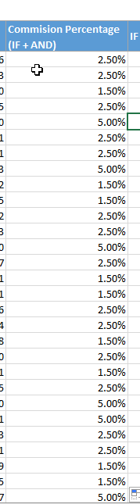

* 1. In column J, enter the formula as below

* 1. Copy paste the same formula to all cells of I

* 1. Enter TRUE and FALSE in column K

* 1. In column L, enter the following

